Note the files are for educational purposes only.

Please let the IBM Support Team know if you would like an IBM Consultant to work with you on a business solution.

============================================================================
DISCLAIMER:
=========================================================================
These sample files are licensed under the International License Agreement for
non-warranted IBM Software and is provided "as-is" with no formal support.

IBM COPYRIGHT INFORMATION:
==============================================================================
International Business Machines Corporation 1997, 2008
Licensed program - Property of IBM. All rights reserved.
IBM and WebSphere are trademarks of International Business
Machines Corporation in the United States and/or other countries.
Java is a trademark of Sun Microsystems, Incorporated.
U.S. Government Users Restricted Rights - Use, duplication, or disclosure
restricted by GSA ADP. Schedule Contract with IBM Corp.

LIMIT OF LIABILITY:
==============================================================================
License to the contained sample application is conditioned upon the recipient
holding a license to the prerequisite product. The license terms and conditions
of the sample/examples are the same as those for the prerequisite product.
Please see the product license for specifics.
==============================================================================

This solution will work if you want to put DataPower as Web Application Firewall before a web application which is written by Struts or other JSP Framework that usually has a lot of redirects to itself. This document steps thru the process of setting up a Web Application Firewall to handle the redirects.

1. Select Web Application Firewall from the Control panel.

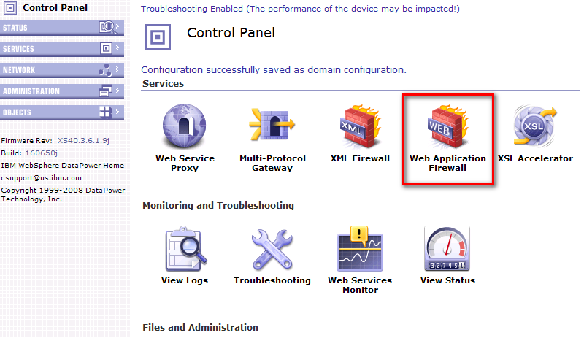

2. Click on Add Wizard

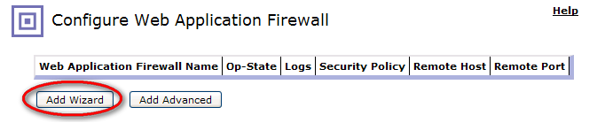

3. Fill in the following information appropriately for your environment. Click Next.

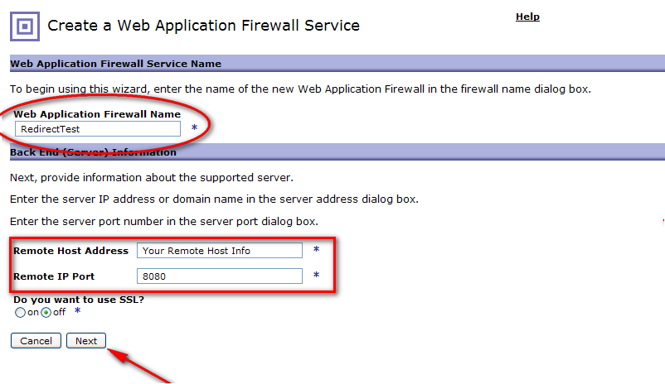

4. Enter in the front end port that will be exposed to clients. Then click Add.

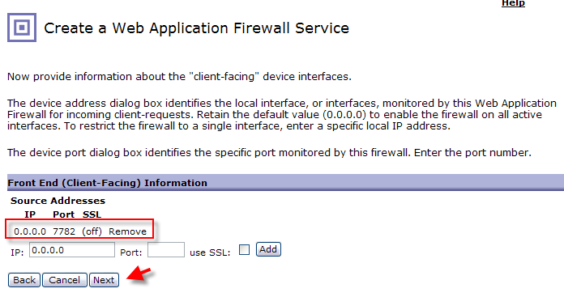

5. Once done adding interfaces, click Next.

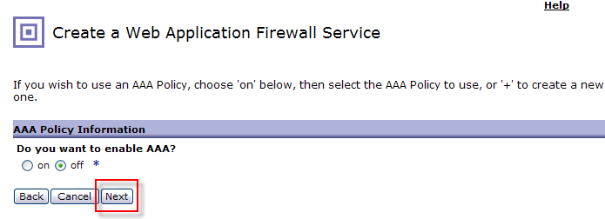

6. Click Next.

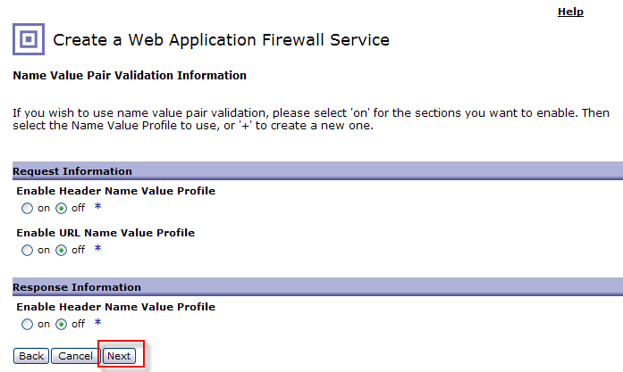

7. Click Next.

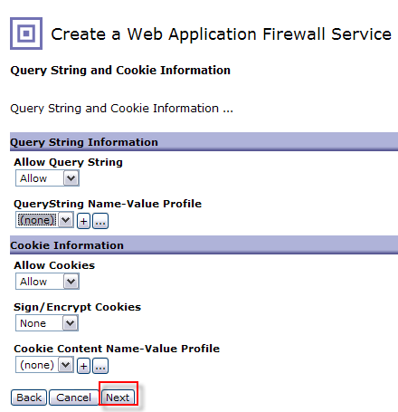

8. Click on Commit.
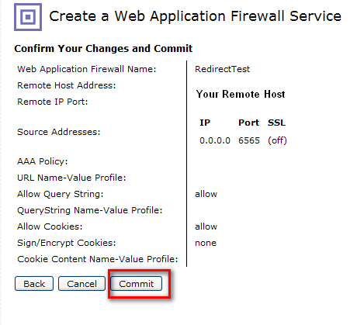

9. Click Done.

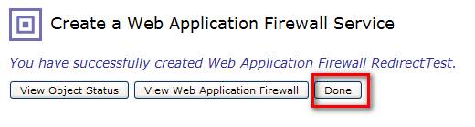

10. Click on Save Config.

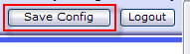

11. Go back to the Web Application Firewall through the Control Panel. And Click on the new object you created.
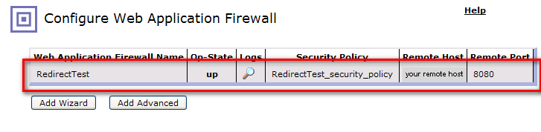

12. On the WAF configuration panel click on the (…) to edit the security policy.
Click on the Request Maps tab. Click on the (…) next to the Request Profile.
Click on the Methods and Versions tab. Make sure the following are selected.
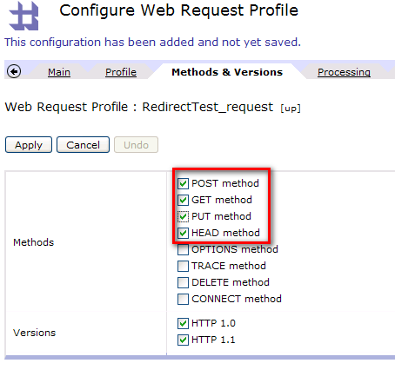

Select the Threat Protection tab. Make sure the following is turned off.
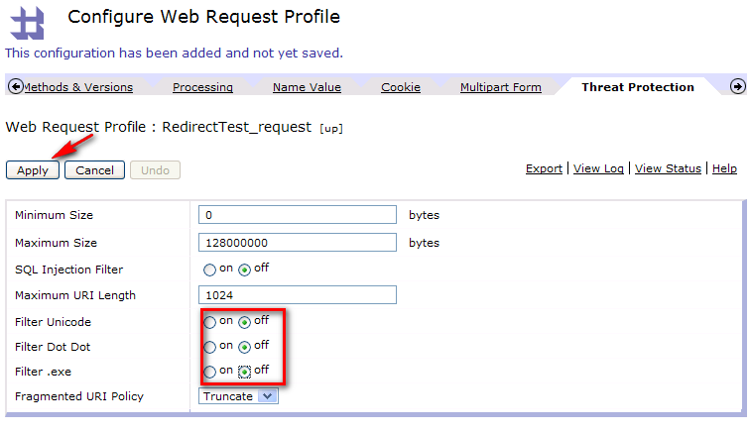
Click Apply.

13. Click on the Response Maps tab. Create a new Matching rule by clicking on the (+).

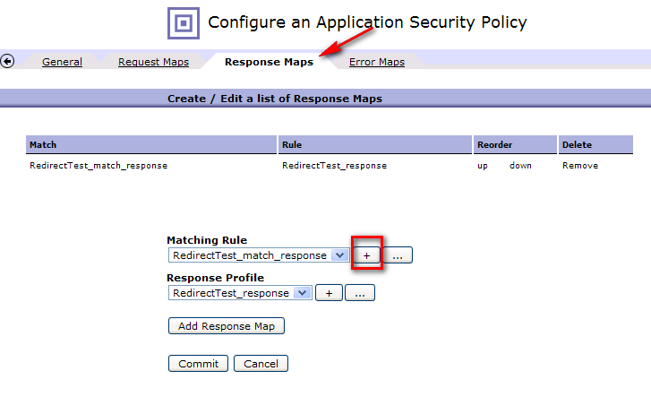

14. Type in a name for the match rule.

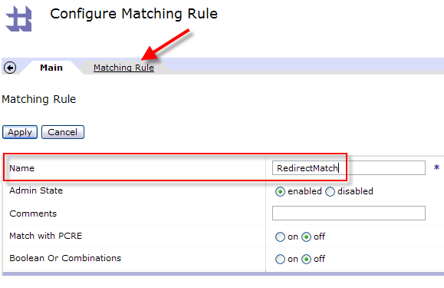
15. Click on the Matching rule tab. Click Add to create a new matching rule. Enter in the following details below and click Save.
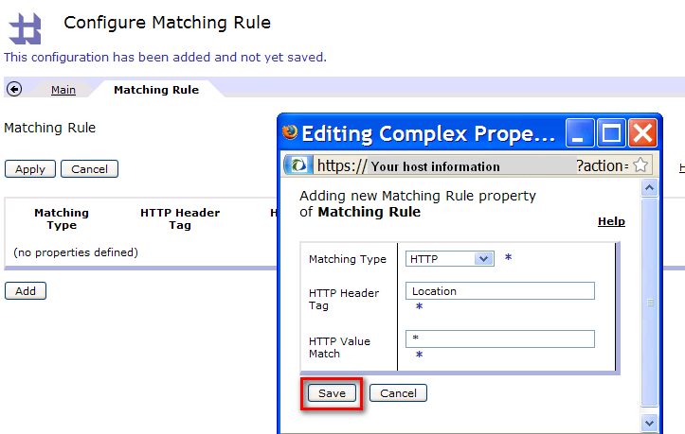

16. Click Apply.

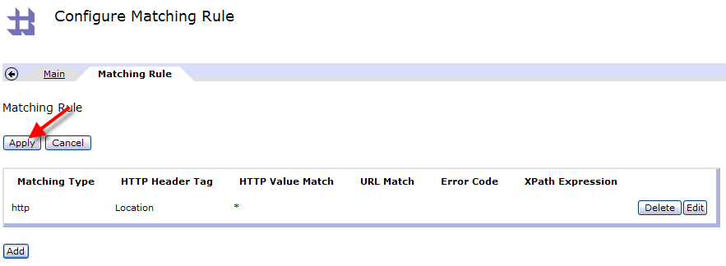

17. Create a new response profile by clicking on the (+)

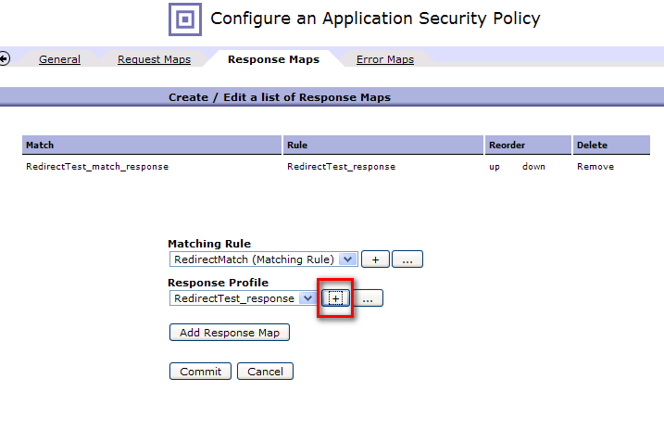

18. Enter in a name for the response process profile.

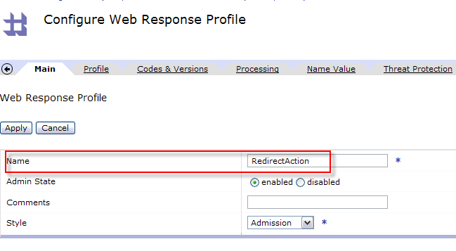

19. Click on the Processing tab. Select Side-Effect Rule from Non-XML Processing.

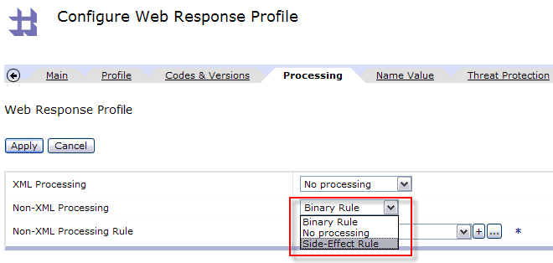

20. Click on the (+) for Non-XML Processing Rule.

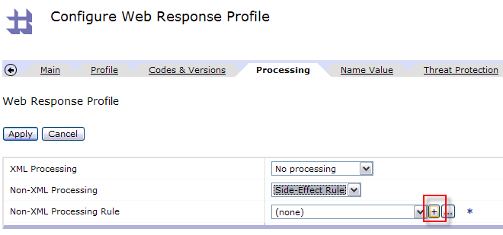

21. Enter in the following information. Then click on the (+) to create a new rule action.

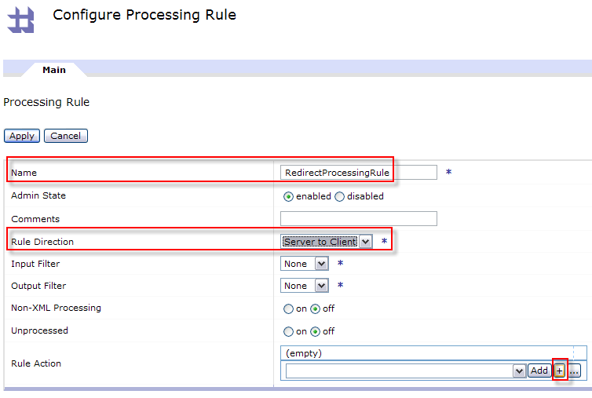

22. Fill in the following information. Click Apply.

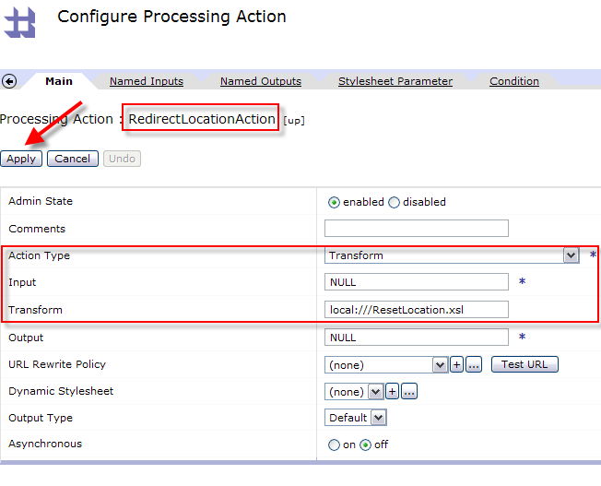
23. With the Rule Action selected in the drop down box click on Add. Then click on Apply.
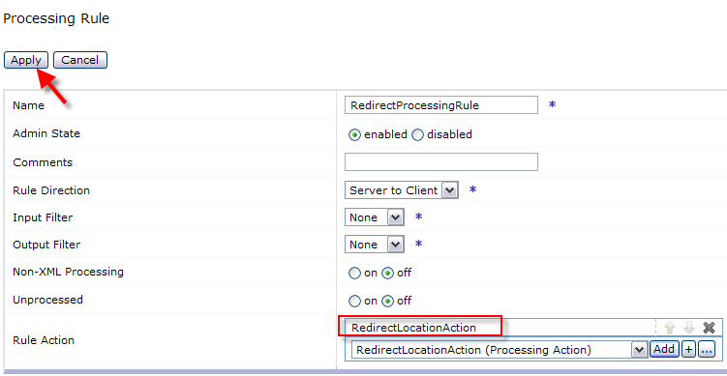

24. Click Apply for all screens until you get to the configure Security Policy screen. Click on Add Response Map with the Matching rule and response profile you just created.

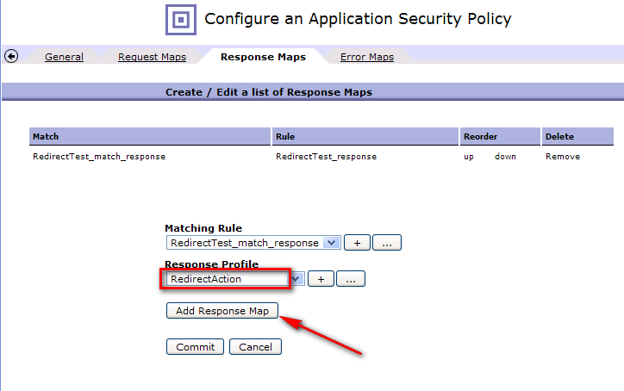

25. The response map should appear on the list. Click on the up link to place it as the first rule.
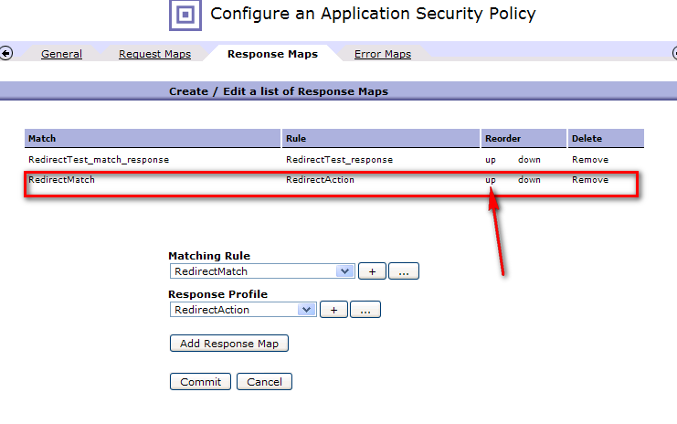

26. The order should now be correct. Click on Commit.

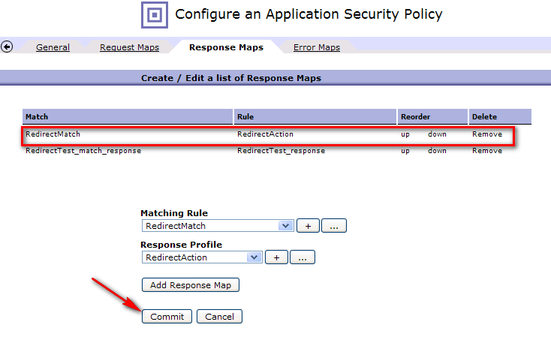

27. Click Done.
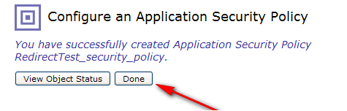

28. Click Apply and Save Config.
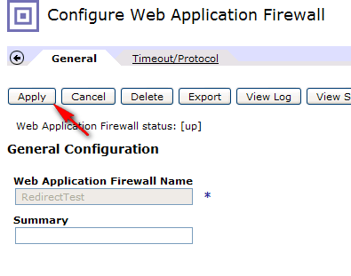
29. Click on Control Panel and then File Management.
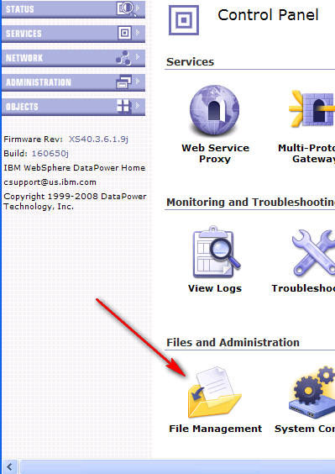

30. Click on the Actions link next to local and choose the Upload Files link.

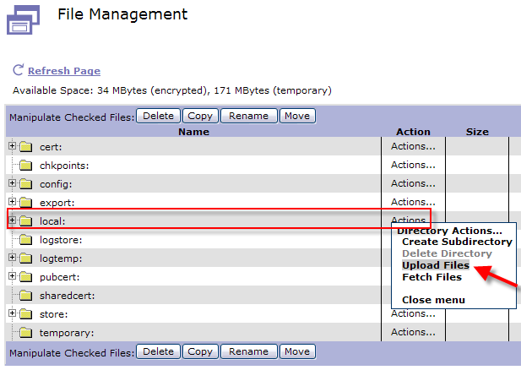

31. Browse and point to the ResetLocation.xsl file that was included with this sample. Click Upload.

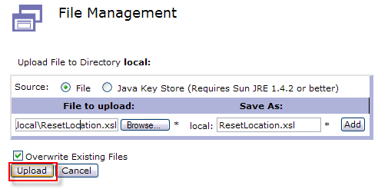

32. Click Continue.

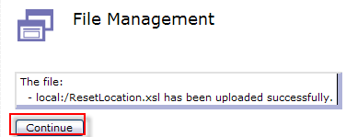

32a. Go back to the File Management view.

Click on Edit next to the ResetLocation.xsl file.

32b. Click on Edit.
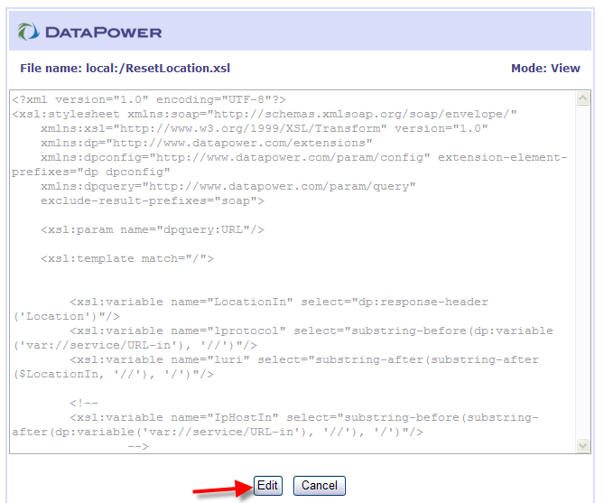

32c. Locate “YOUR_DATAPOWER_HOST_HERE” and replace it accordingly. Click Submit and then Close.

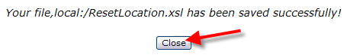
NOTE: This stylesheet will handle simple cases you may have to add additional logic to handle your specific needs.

33. Click on the Objects menu.

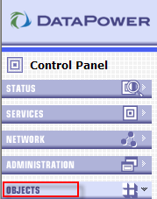

34. Scroll down to the Services section and select Web Application Firewall.

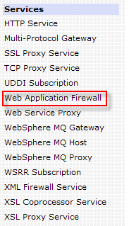

35. Click on the WAF that you created.

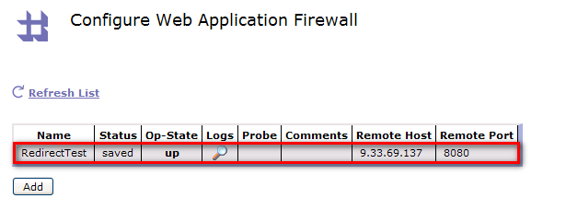
36. Click on Proxy Settings. Set Normalize URI to off.
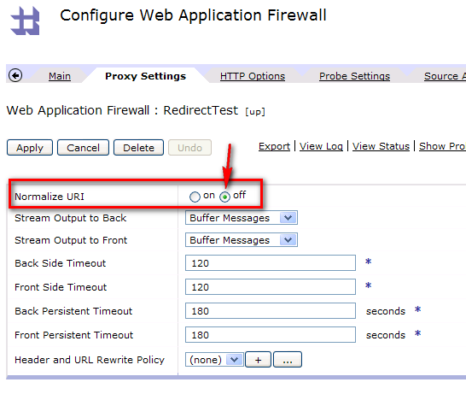

37. Click on the HTTP Options tab and then turn off Follow Redirects. Click Apply and Save Config.

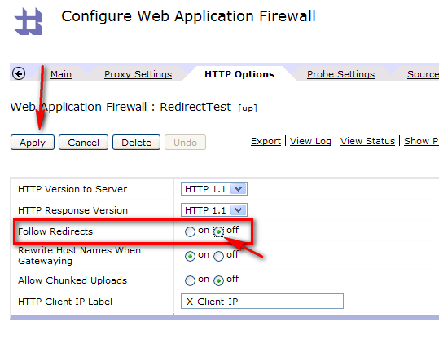
37. You are now ready to test. Go to http://<datapower-ip>:<front-side-port-from-step-4>/

