Prerequisites:
Selenium IDE installed on Firefox on your ‘recorder’ machine
APM 8.1 synthetic agent (product code sn) installed on your ‘player’ machine

PART 1 - Selenium script recording:
Launch Selenium IDE from Firefox browser:
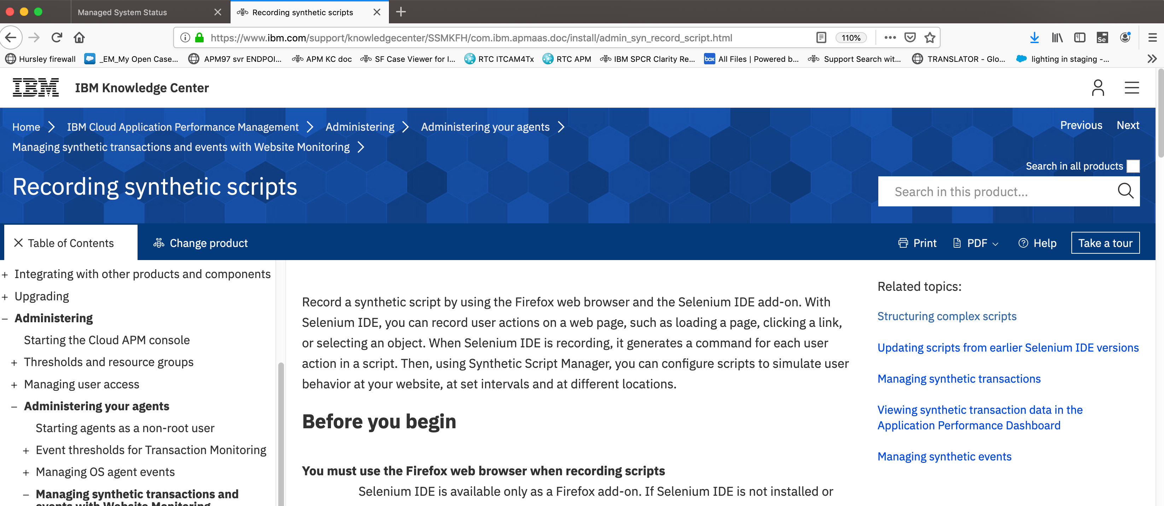
Create a new project:
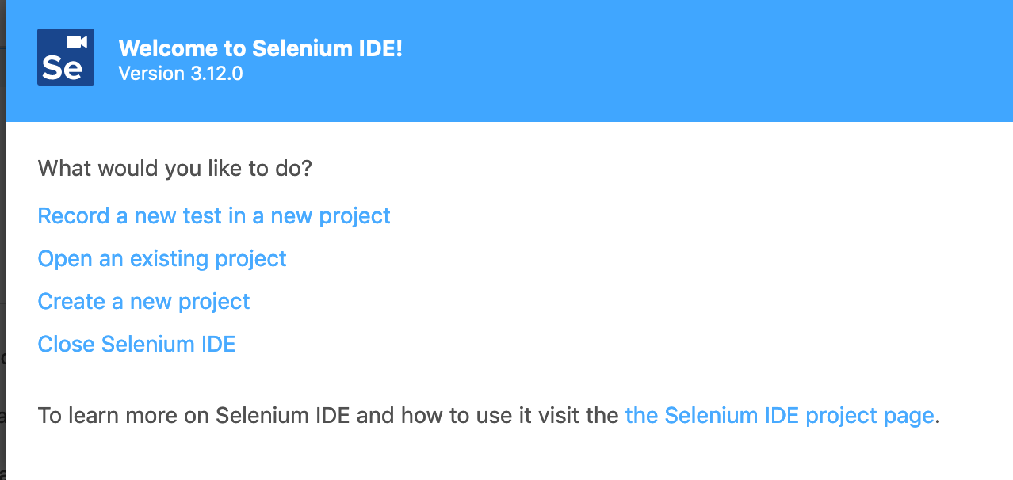
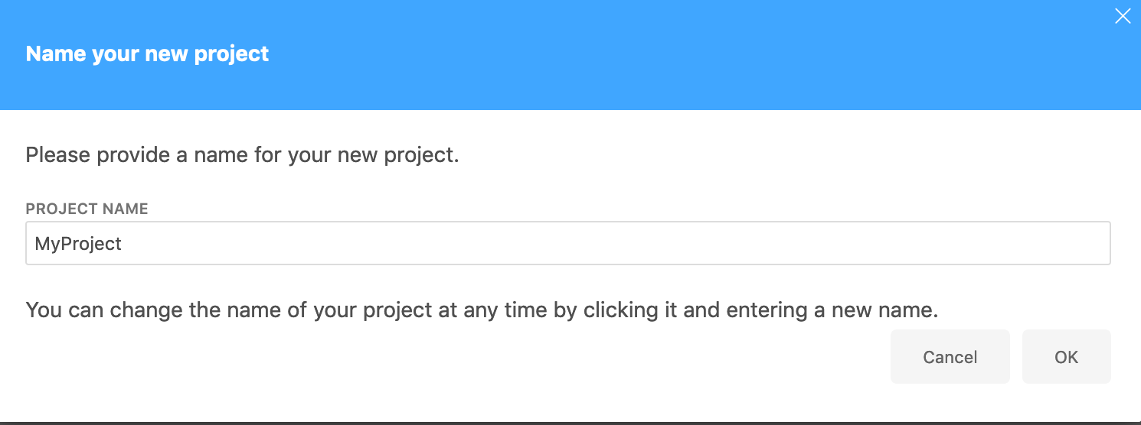

Enter your base url that the target of the server to be monitored e.g. http://www.ibm.com
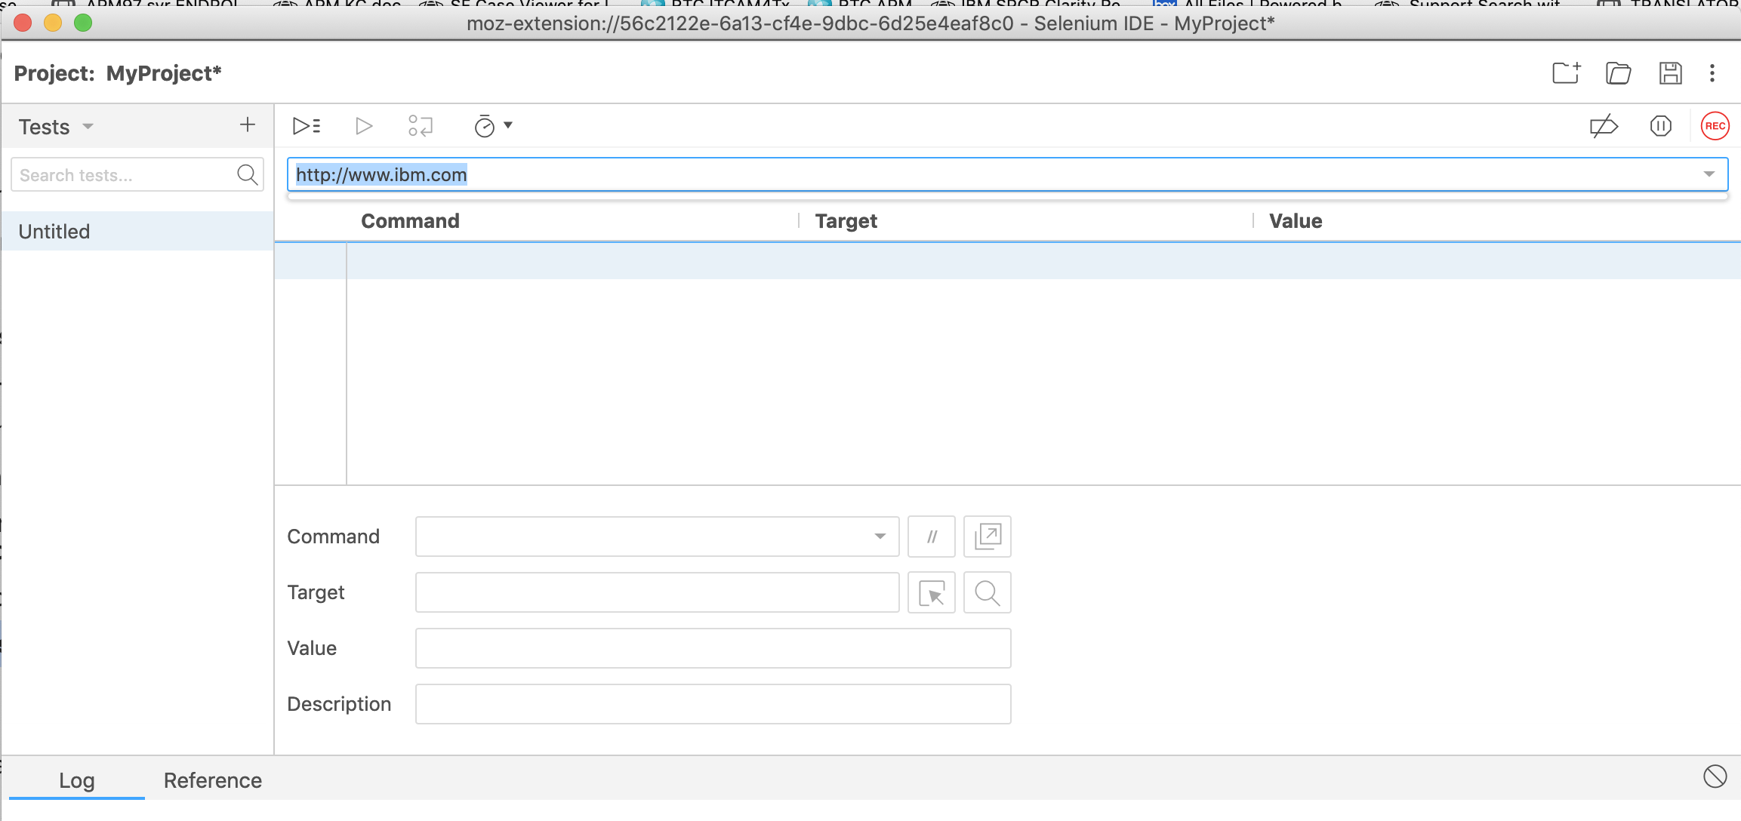
Then click the REC button…

Then record the steps you are interested in by navigating in the newly opened Firefox window, like for example:
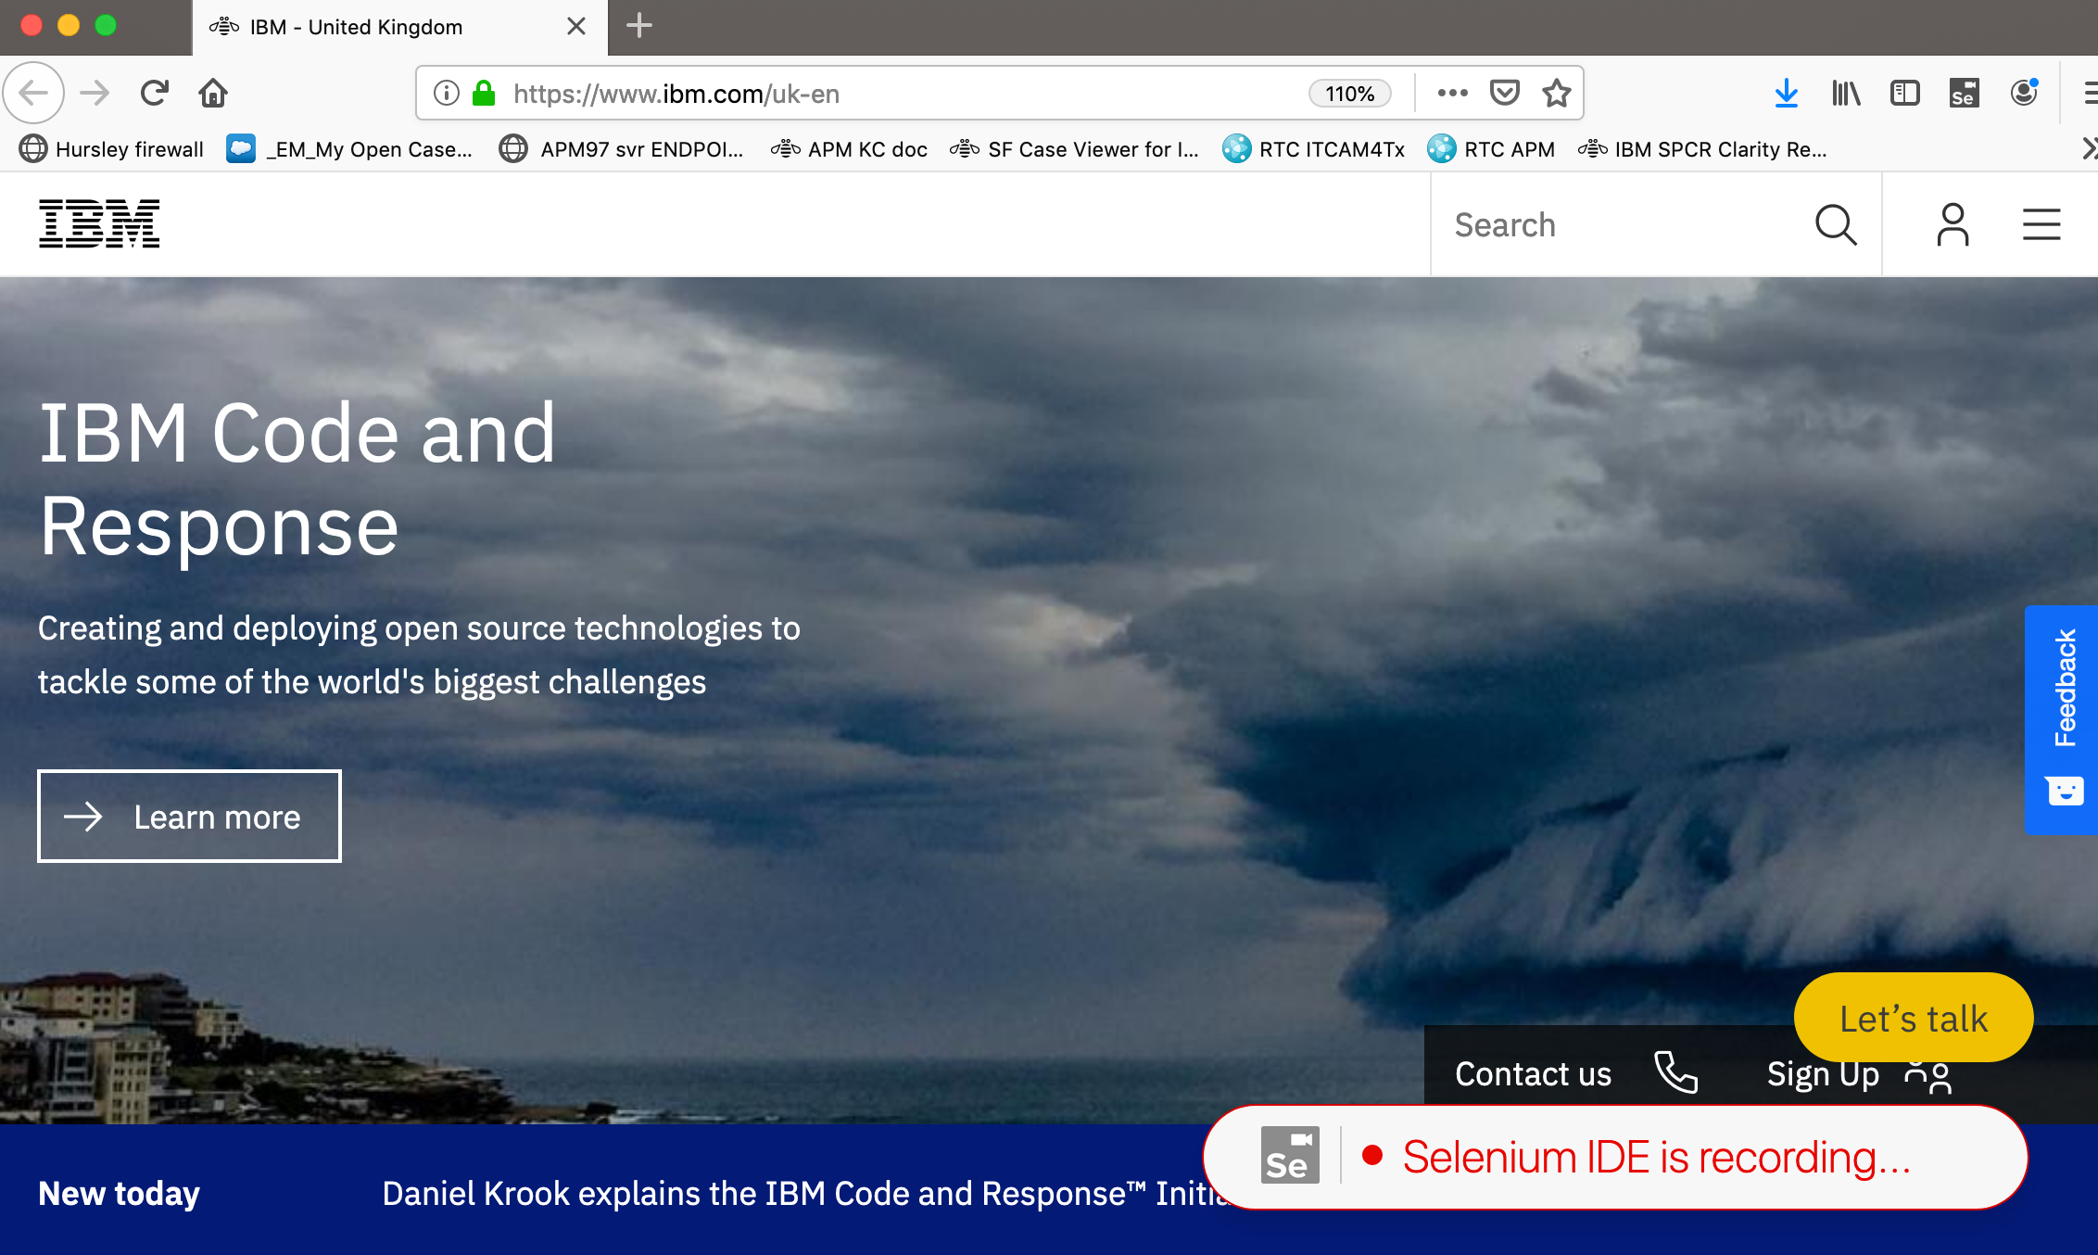

You can Right Mouse Click in the above recorded window, and then select some selenium commands that can be inserted inside your script, on the fly, like ‘Assert title’ command for example:
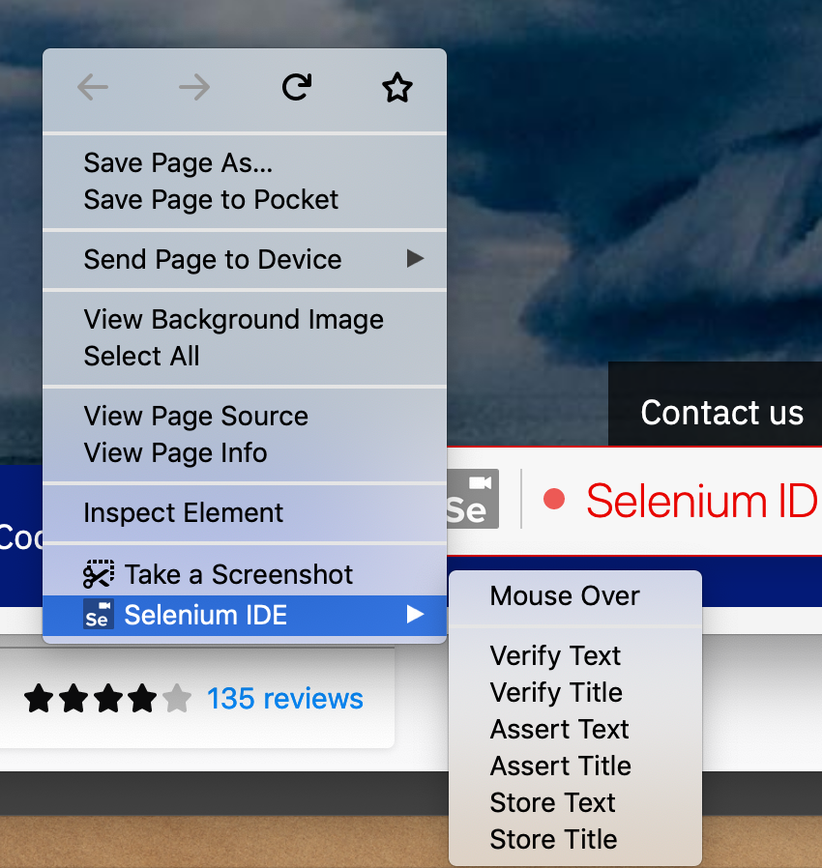

Close this above window when you have finished to record your steps…

Then stop the recording…
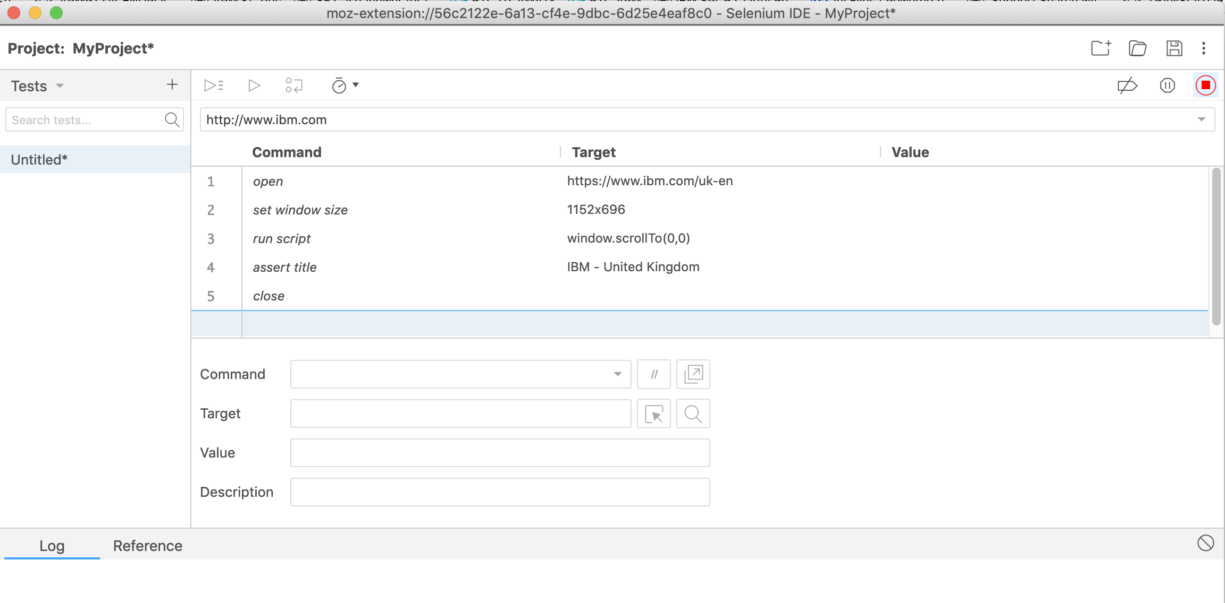
Save your script and put a name…

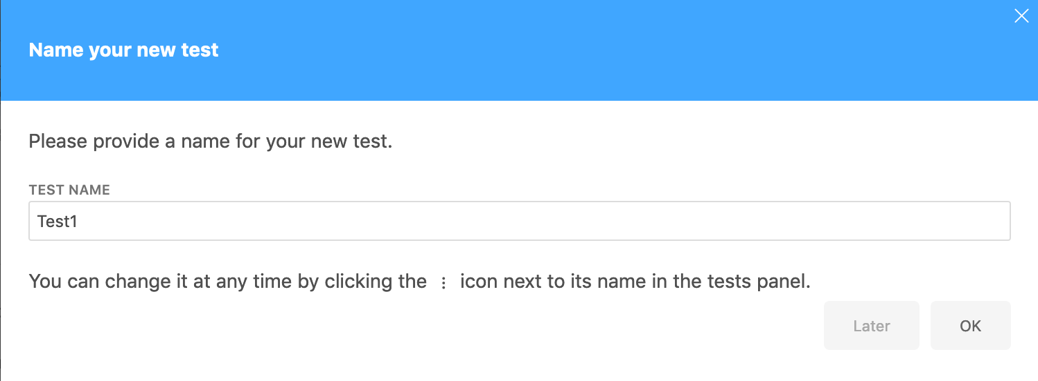

Customize your script if needed, add/ remove commands manually, etc…
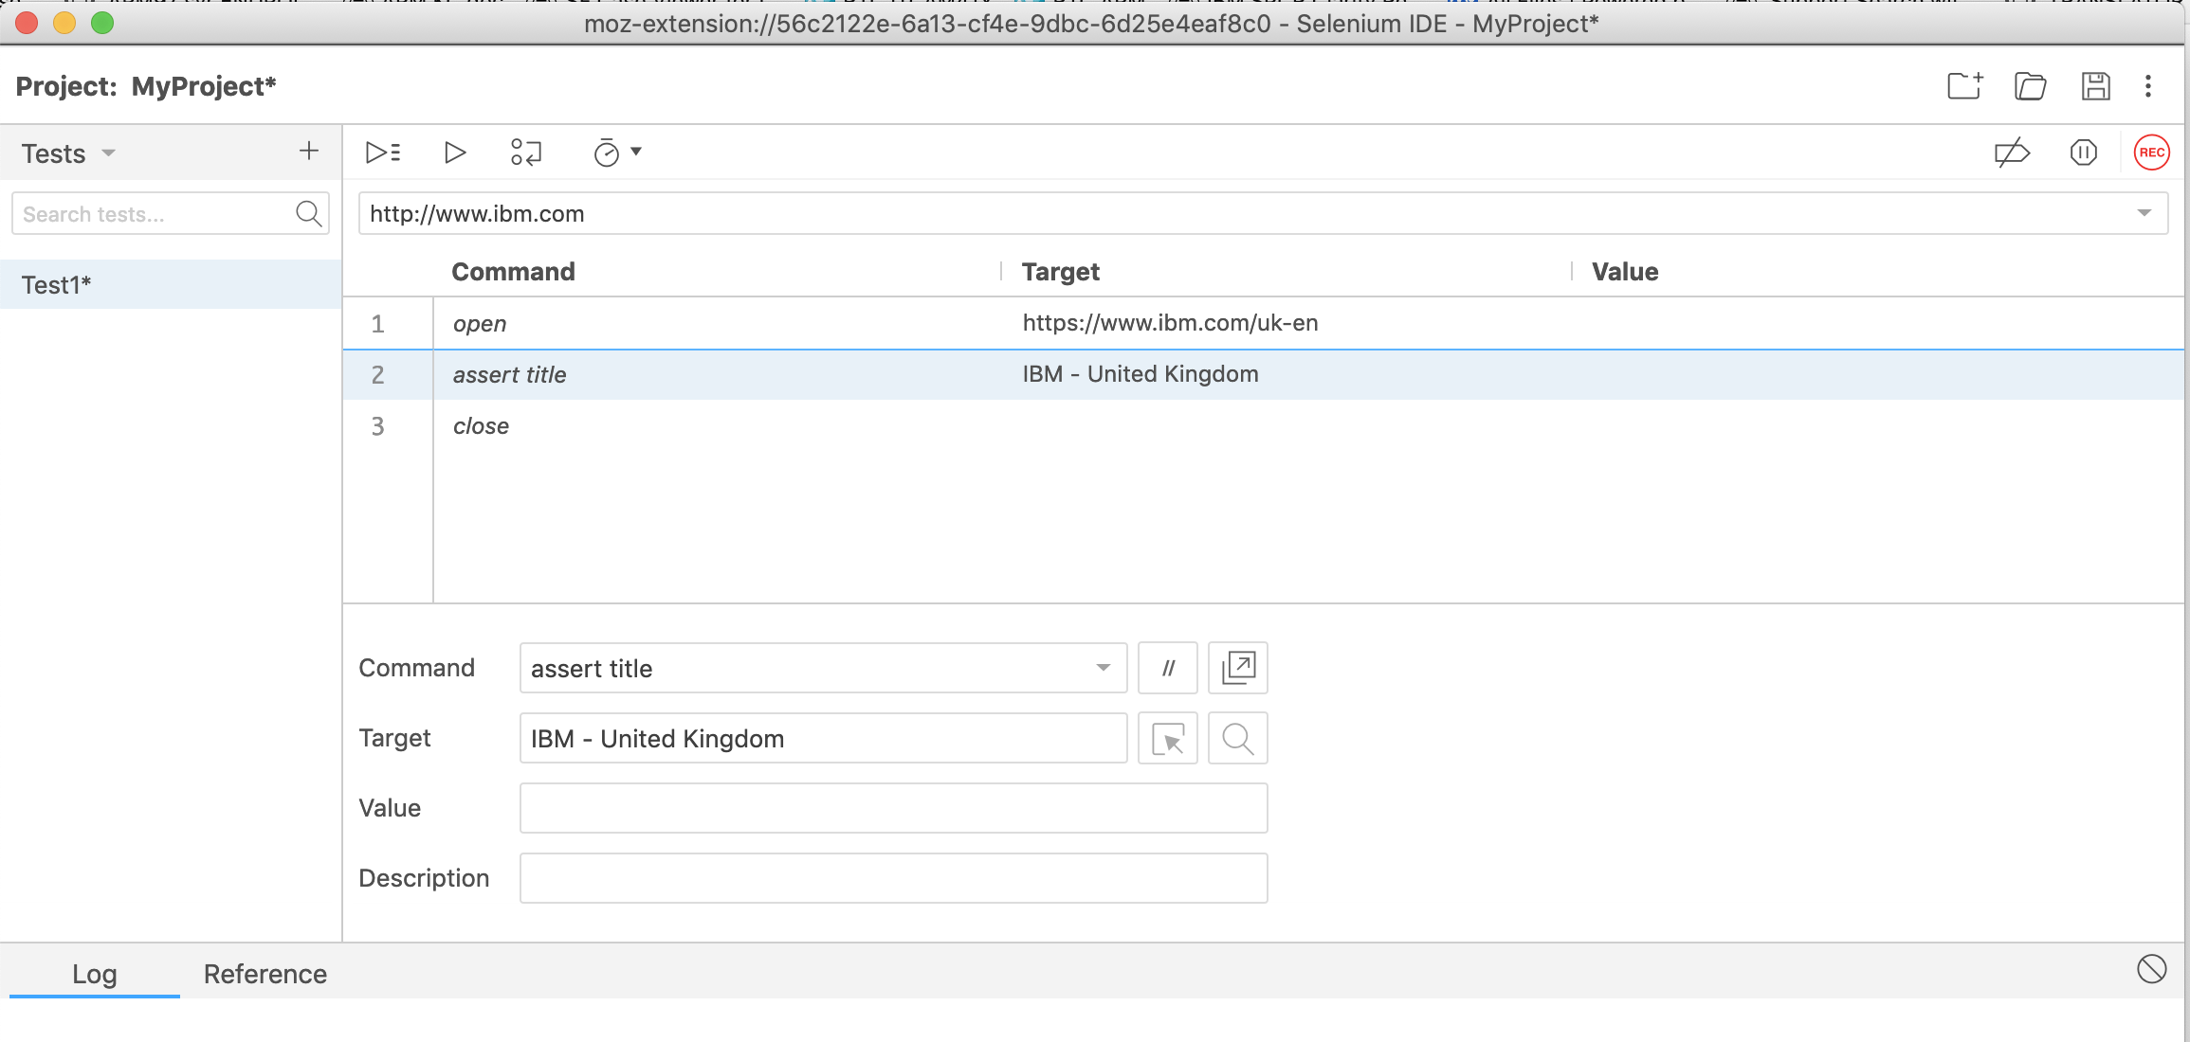

Execute your script and verify all is ok:

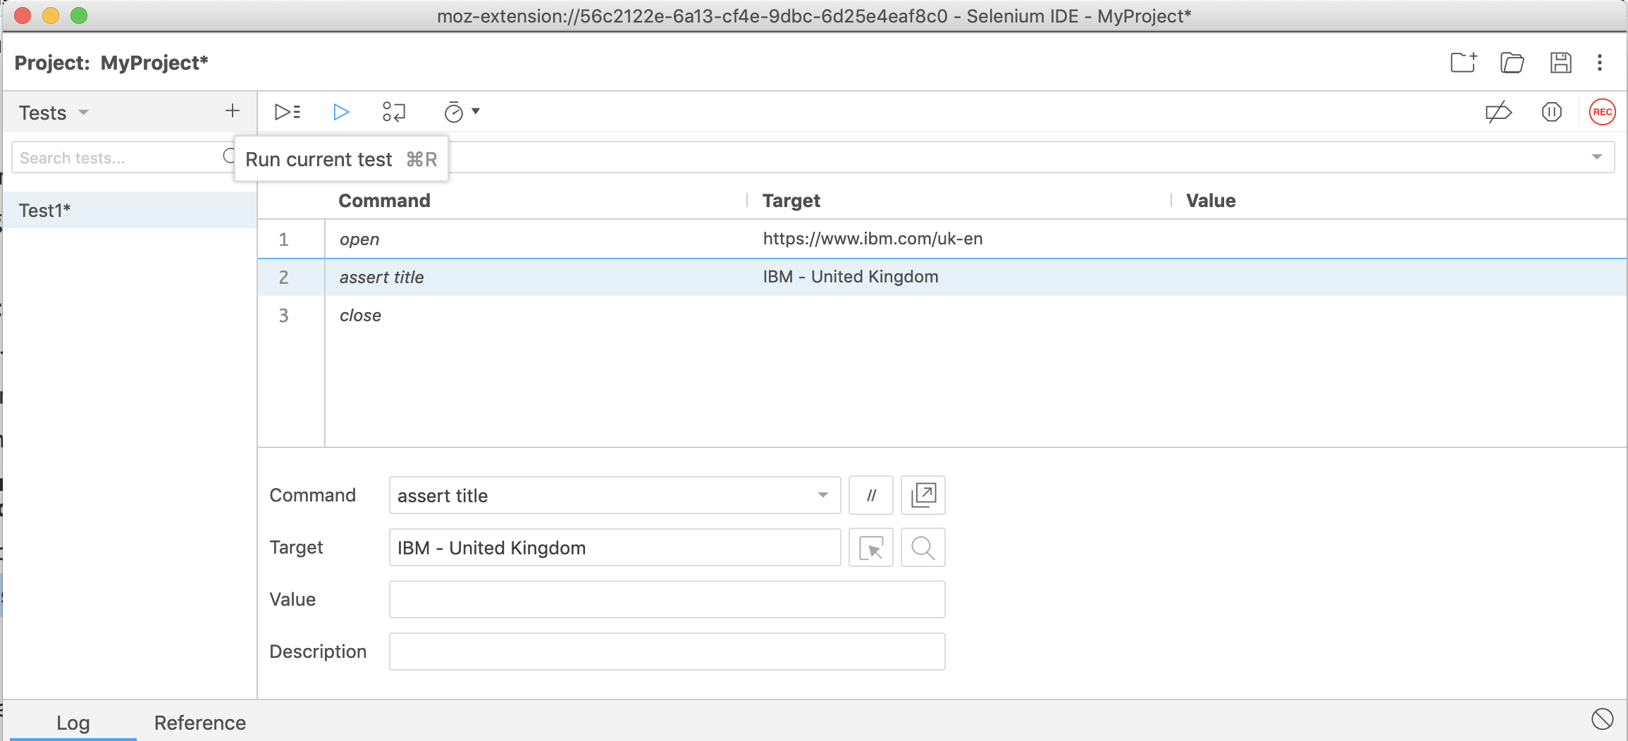

Verify execution results:
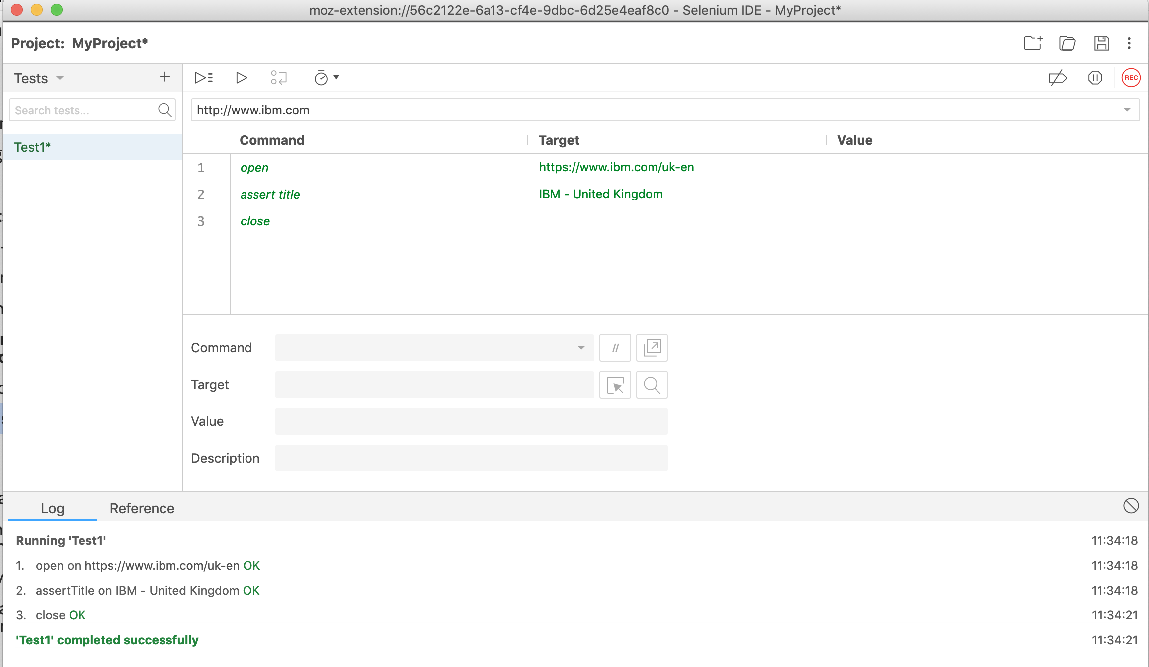

Save your project on your local machine:
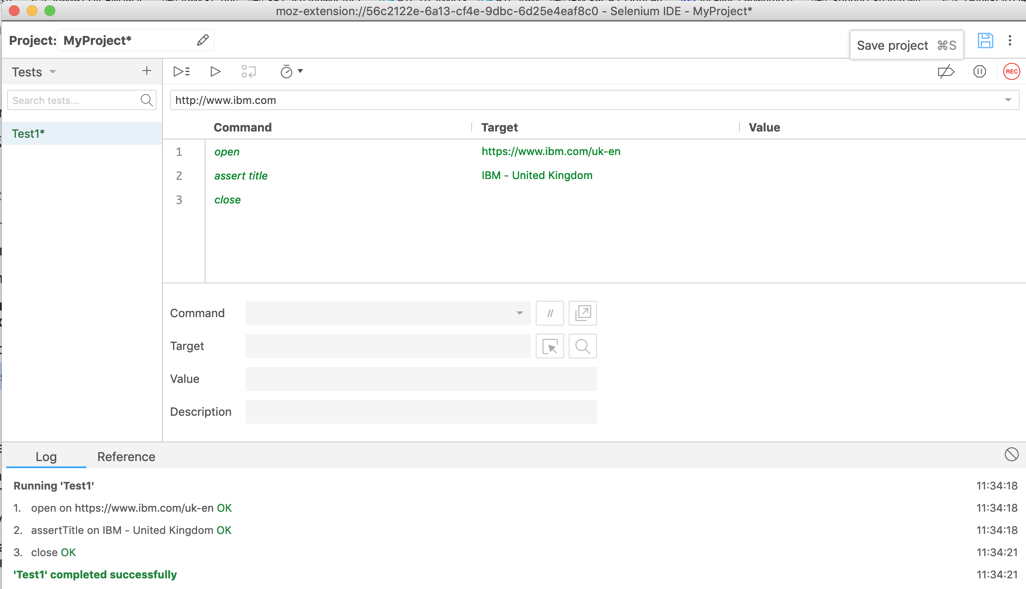

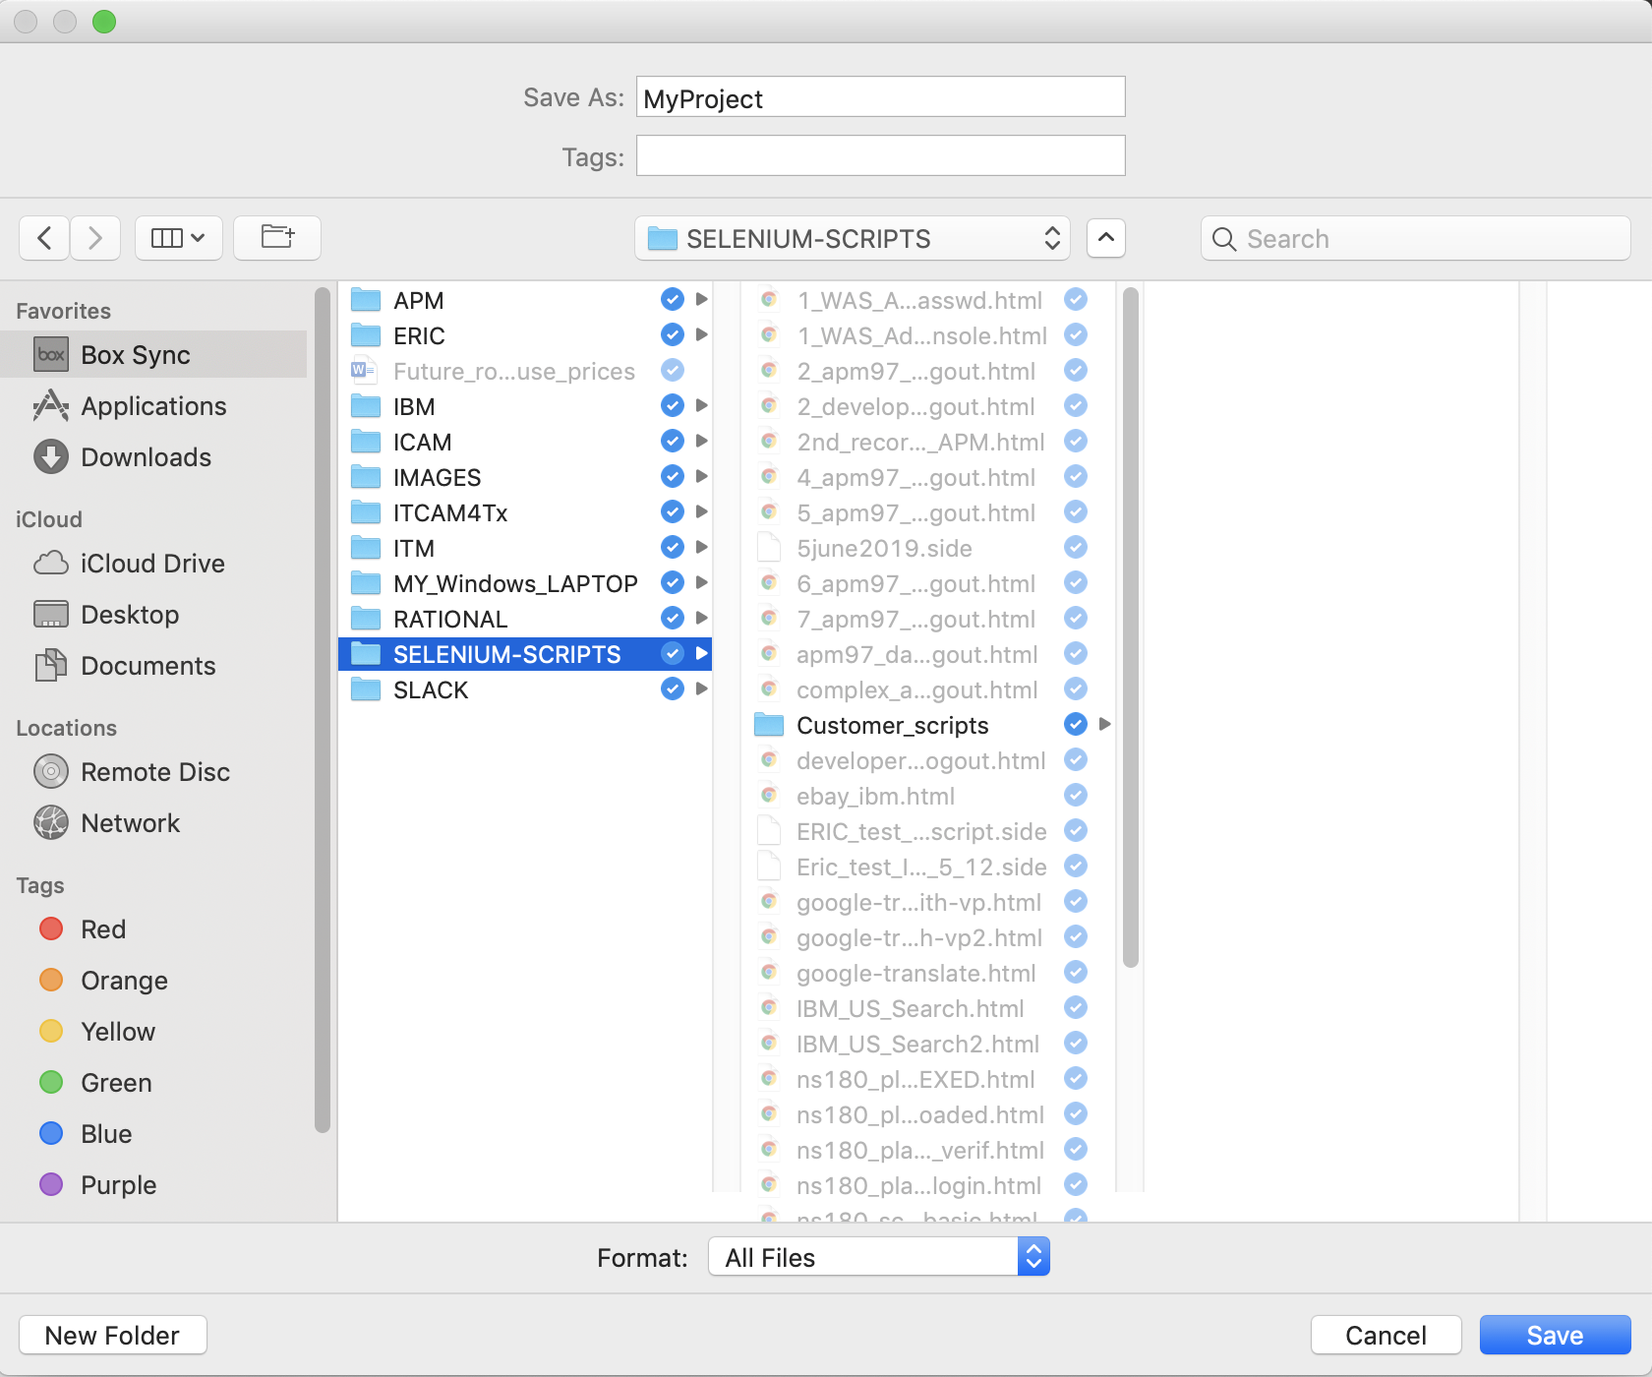

If all went ok, your script (e.g. Test1) should also have been added to a Default Suite, visible when accessing ‘Test suites’:
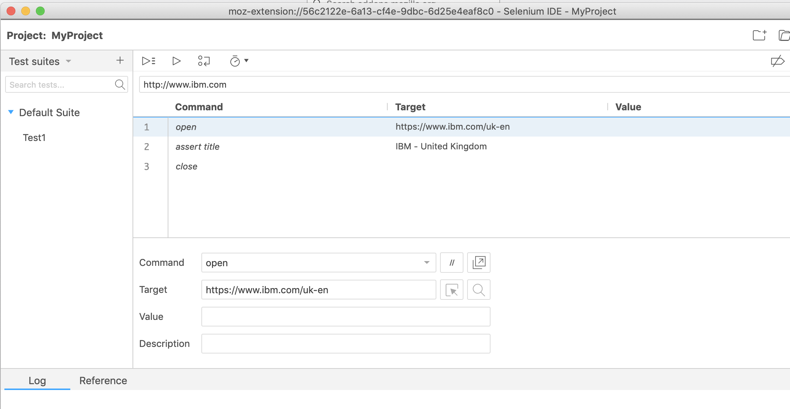

If that is not the case, you can add your script into a test suite manually, by selecting ‘Add tests’ option available under the 3 vertical blue dots icon, right to ‘Default Suite’:
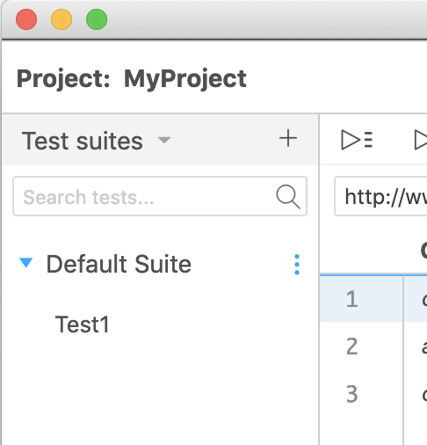

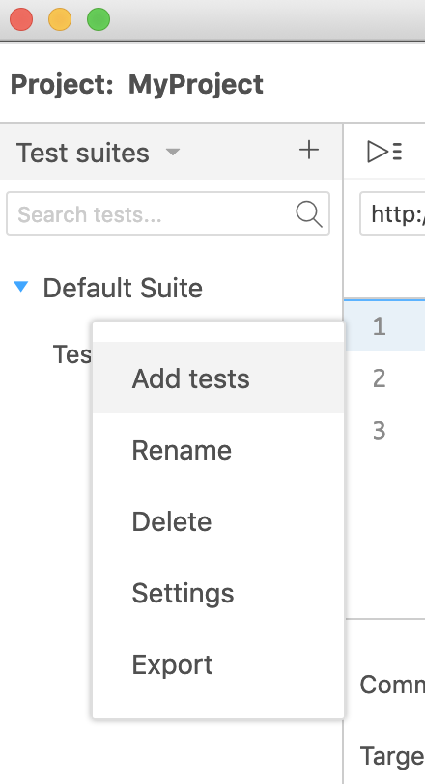

Then save again your project.

Close Selenium IDE:

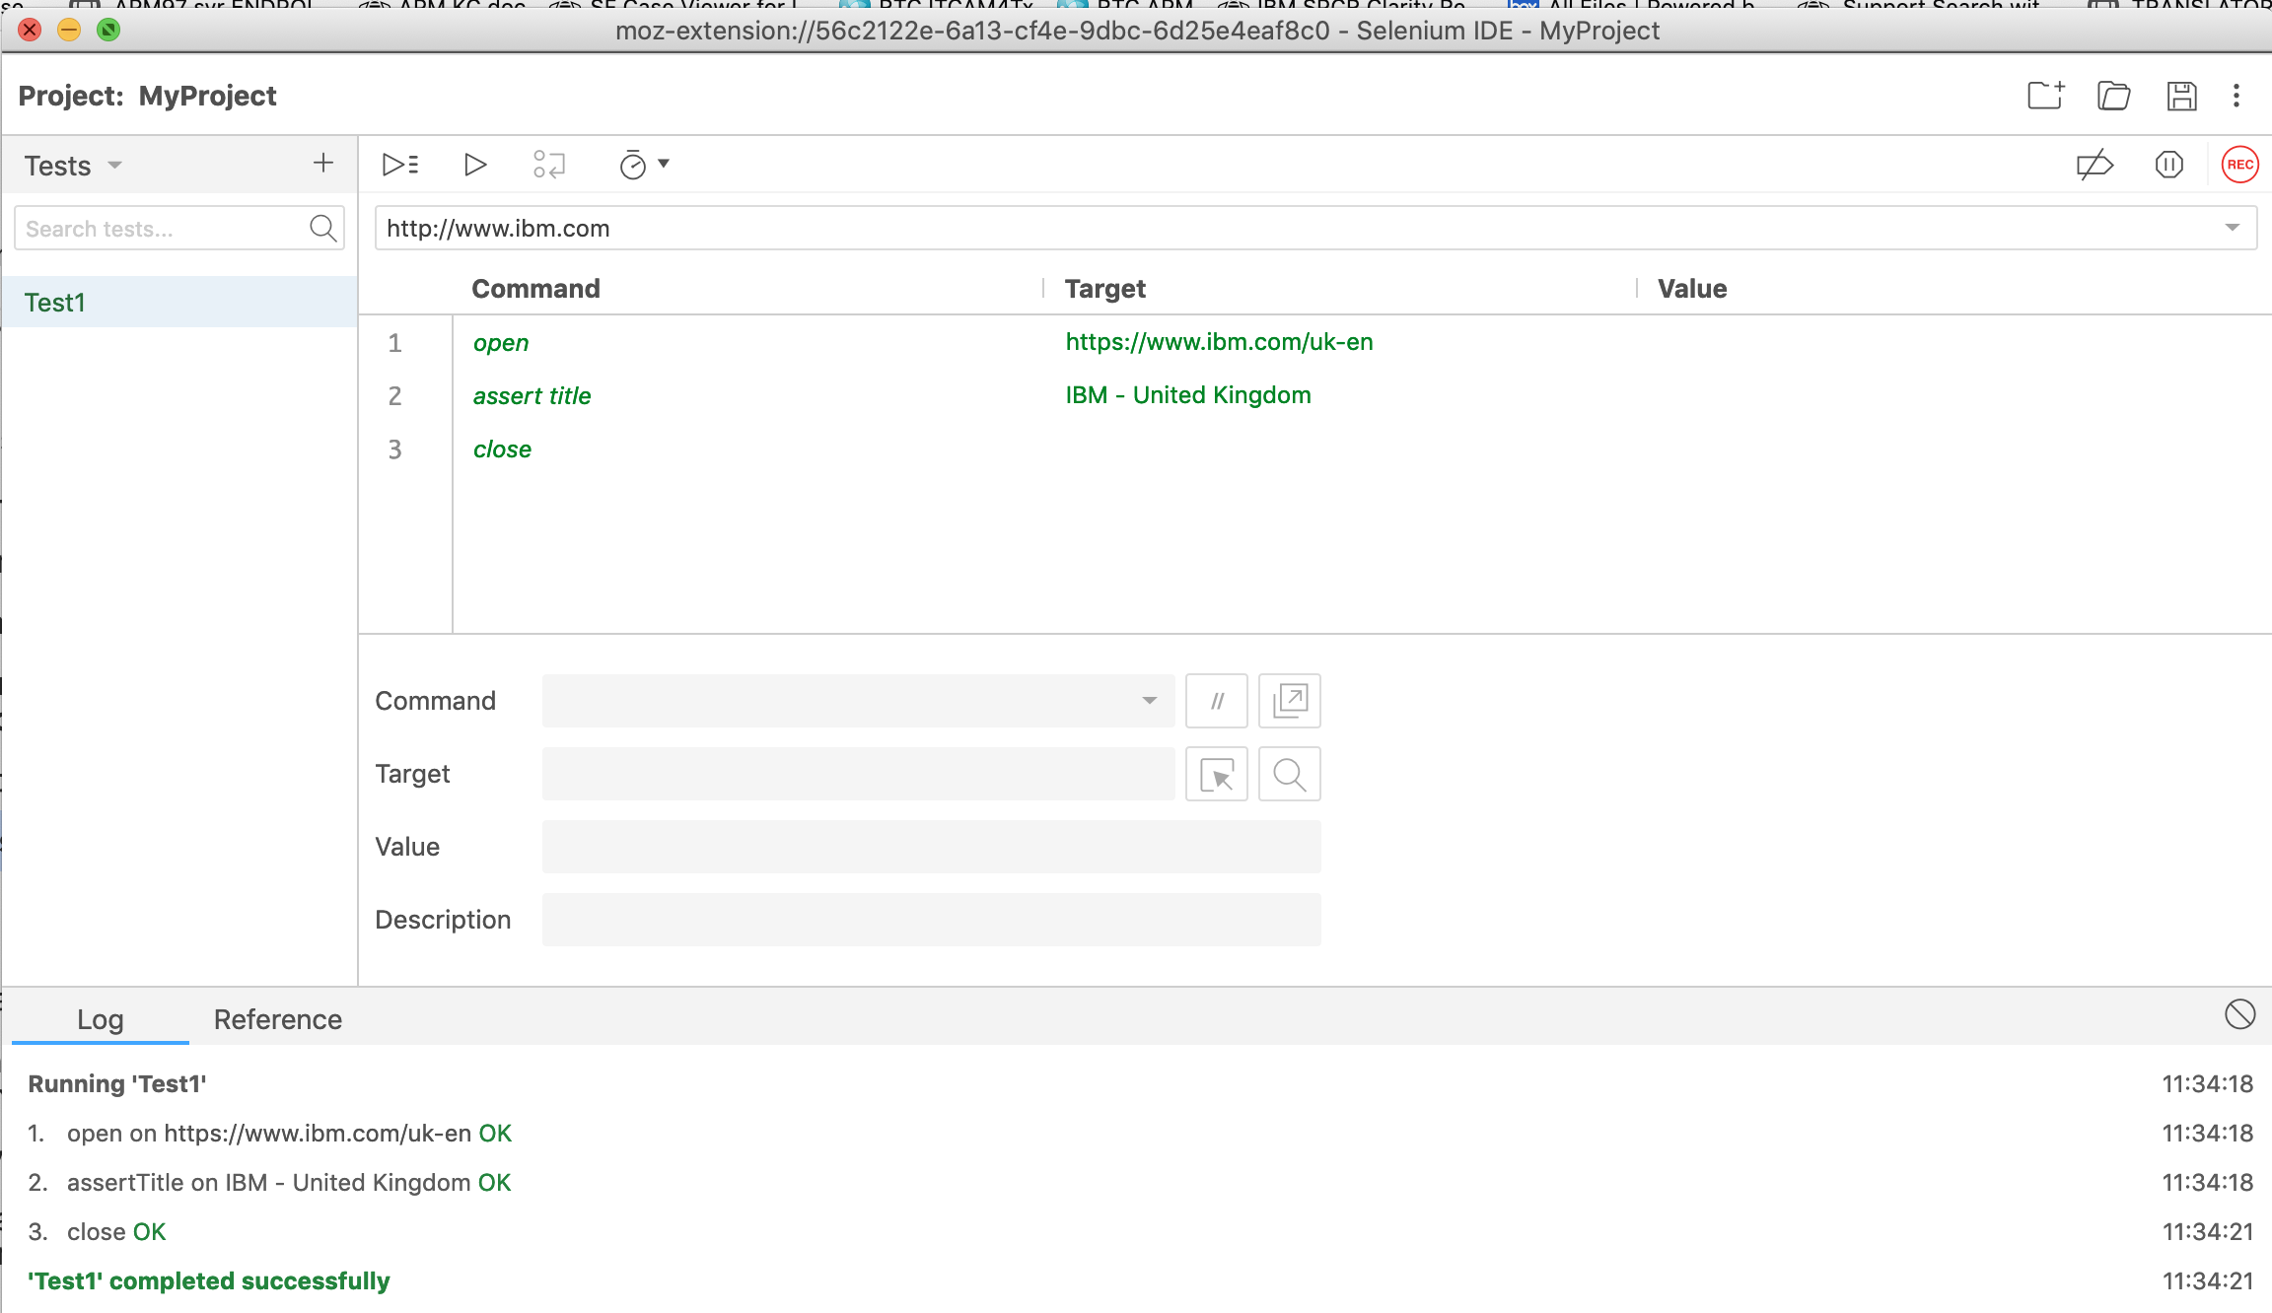
Selenium recording is now finished….

PART 2 - ENABLE this script on IBM APM 8.1 environment/ upload the script

From the local machine where you recorded and saved your Selenium script, e.g. <project>.side file, open an internet browser and access the APM UI console url, like:
https://<apm_server>:8099/authenticate/

And access System Configuration -> Synthetic Script Manager -> Synthetic script Editor:
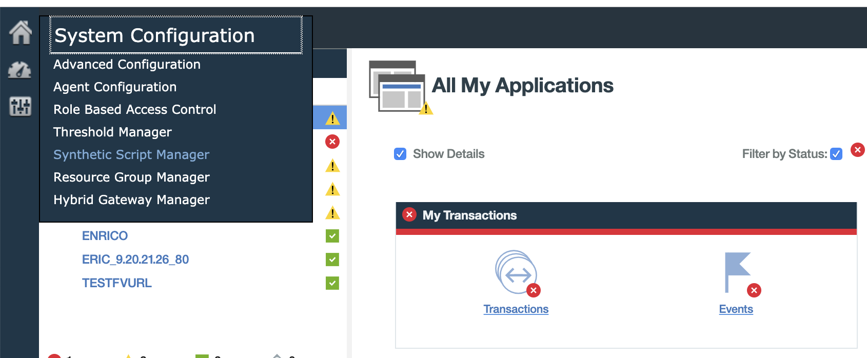
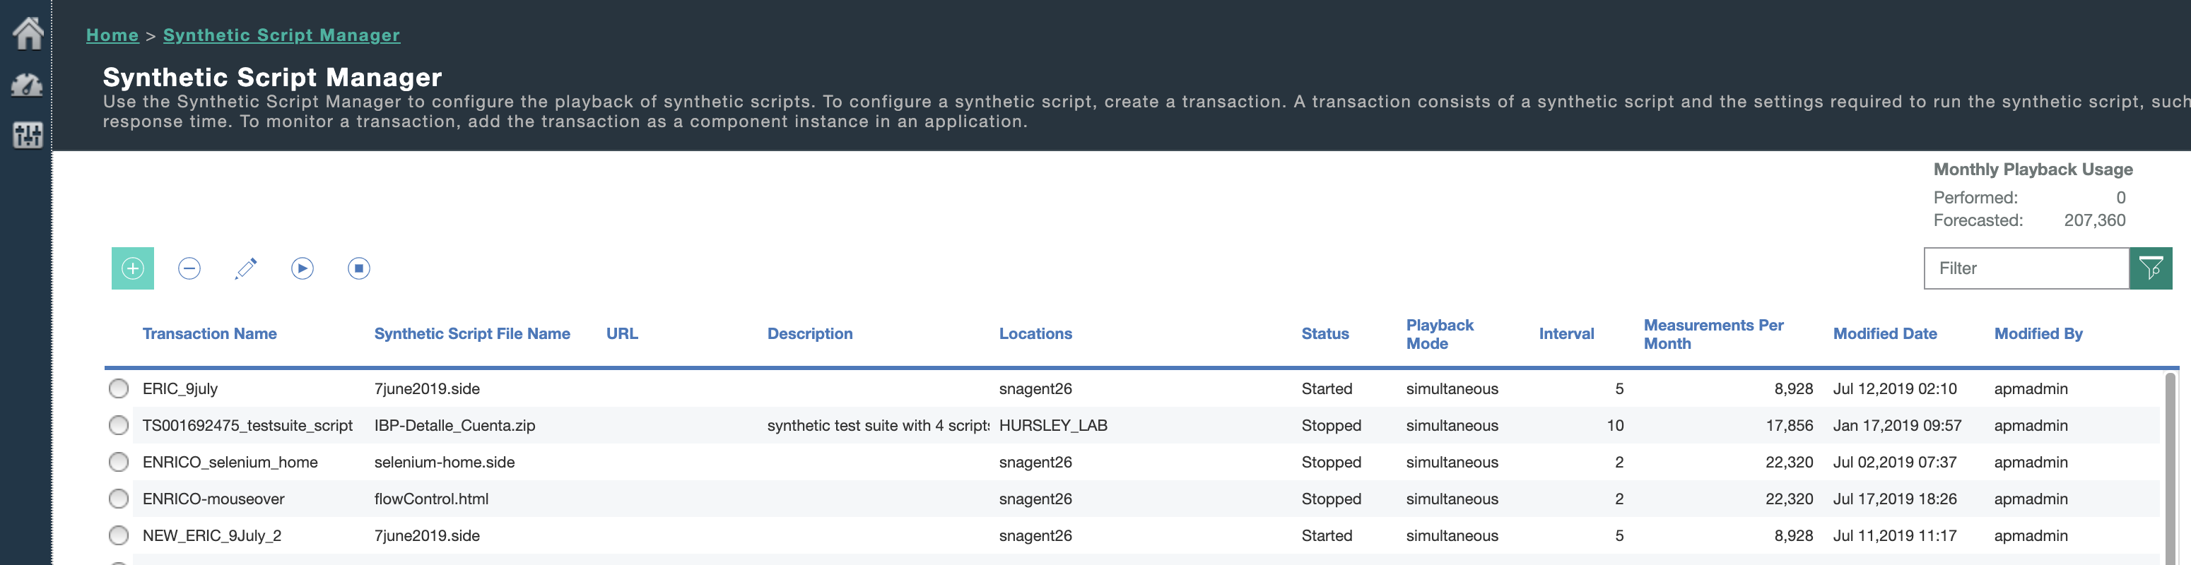

Click on + sign above to create a new transaction, put a name, a description, and press ‘upload script file’:
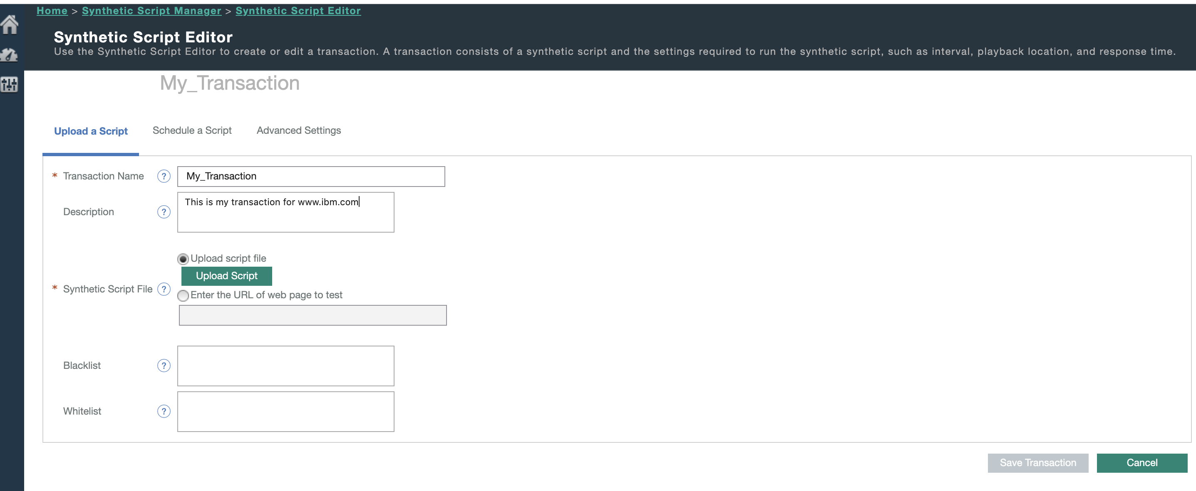

Select your selenium script .side file or similar, that was saved during Part 1:
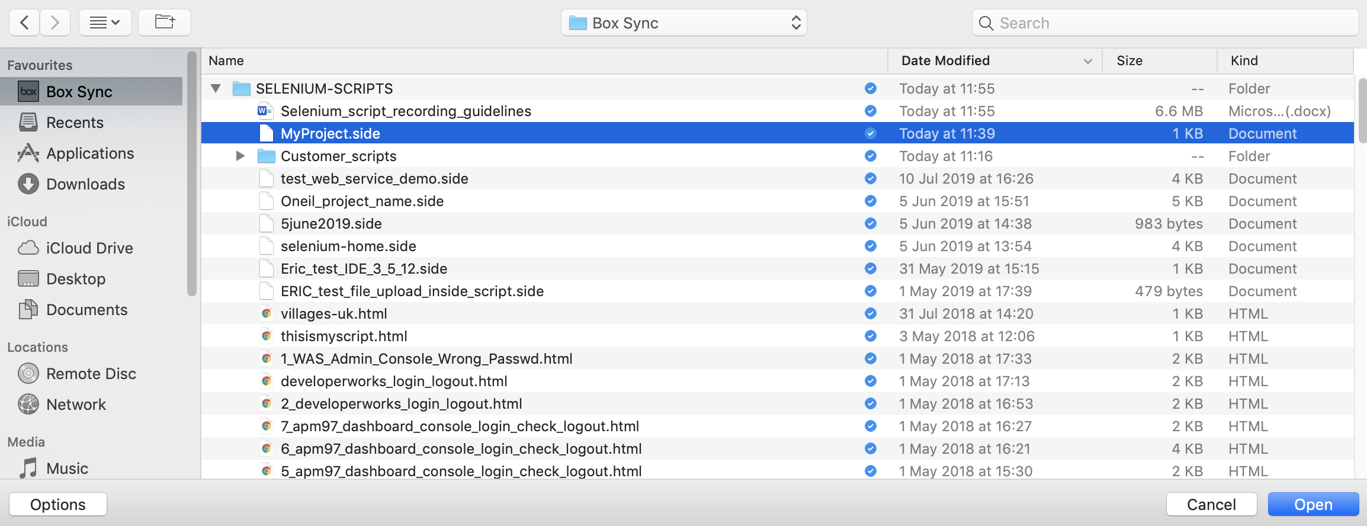

Results:
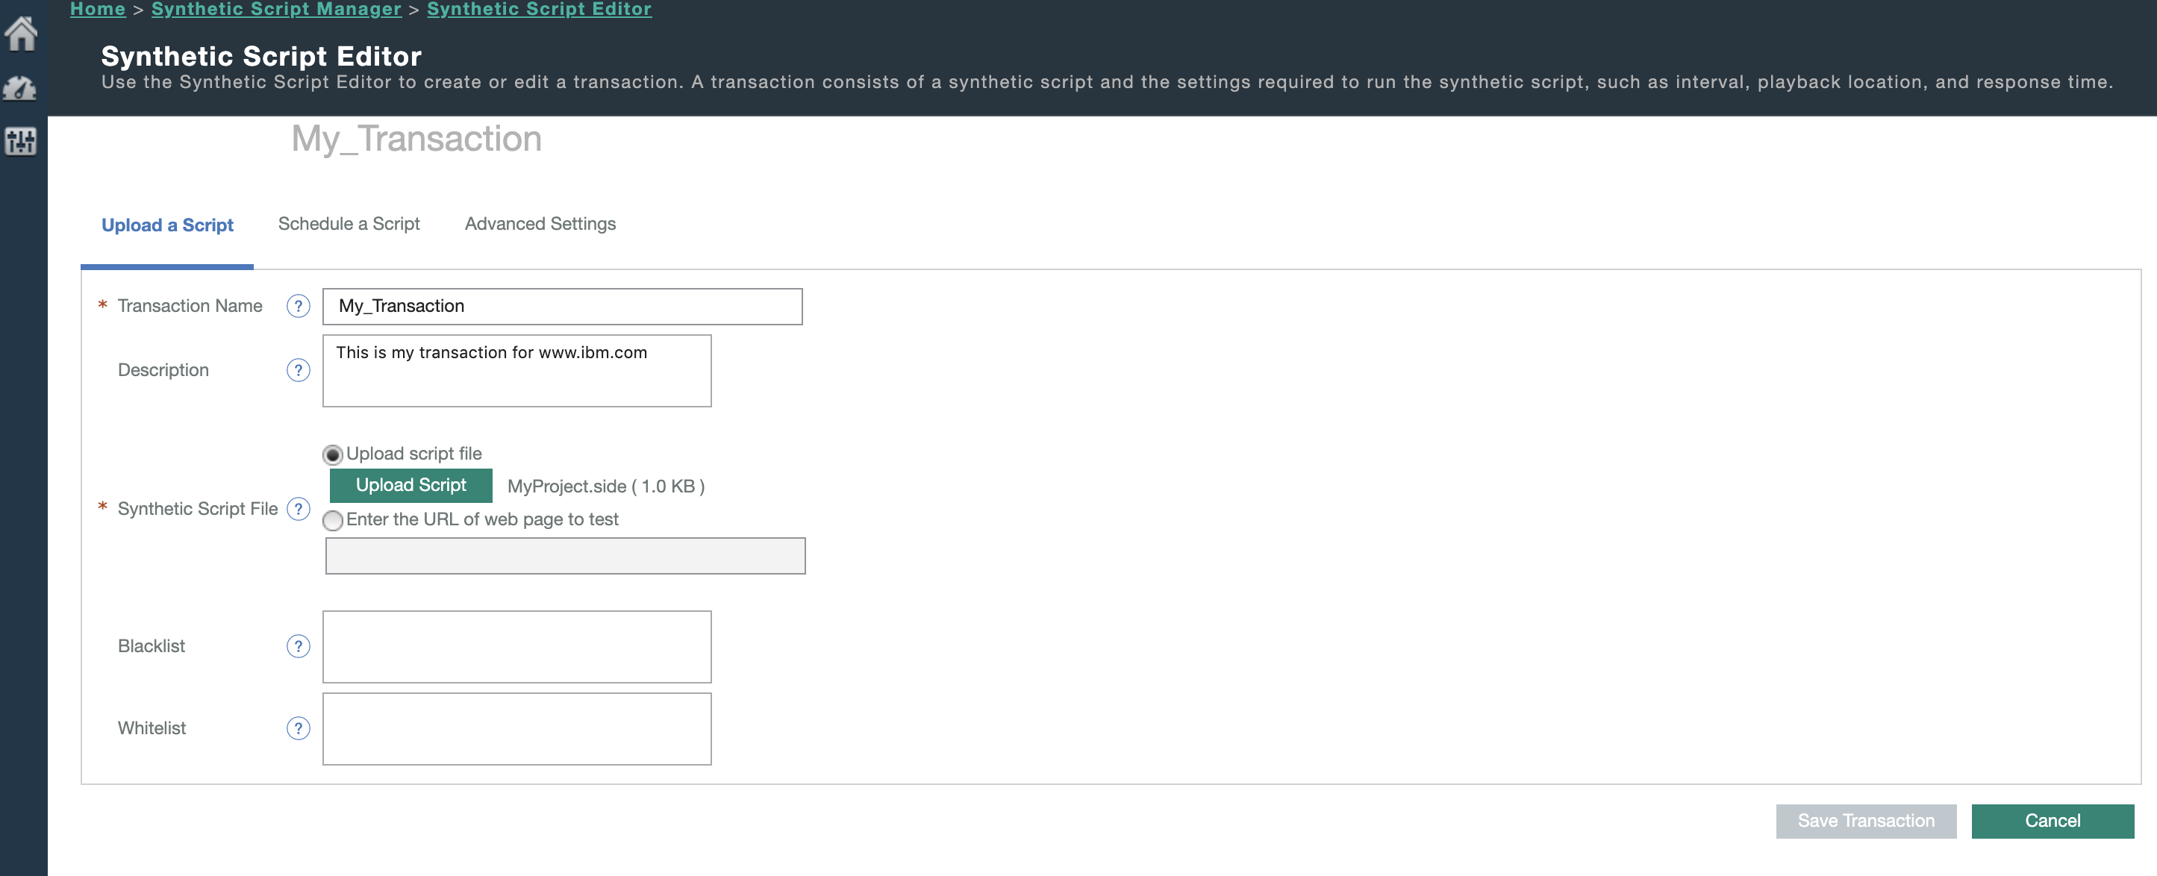

Select ‘Schedule a Script’ tab, set the playback mode, interval, and select the synthetic agent endpoint(s) where the script needs to run:
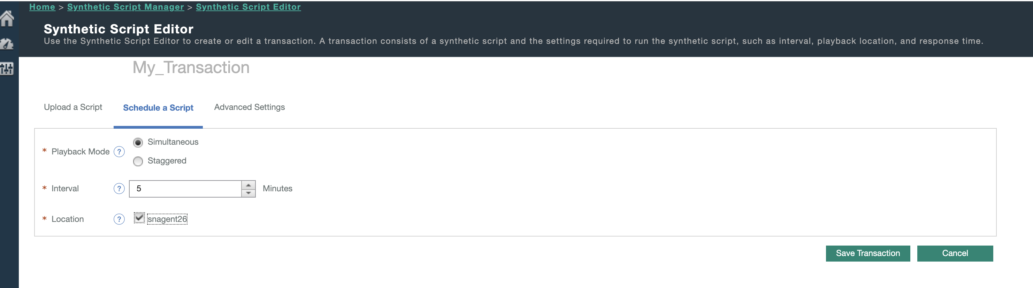

Select the ‘Advanced Settings’ tab, your script’s transaction should appear under Transaction name, then save your transaction:
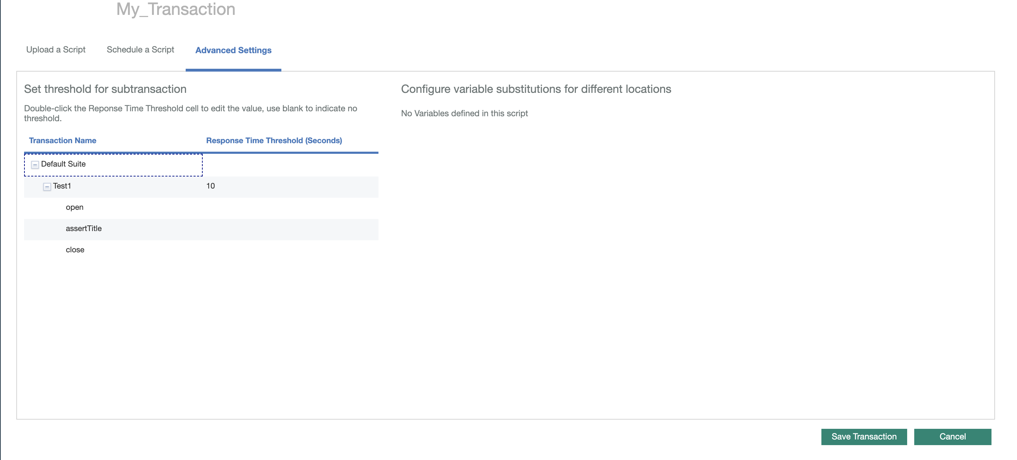

Remark: you can select a transaction step in the above screen, like open, assertTitle, etc, and if you click in the area below the column Response Time threshold, you can the customize and set a threshold for a sub transaction of your script.
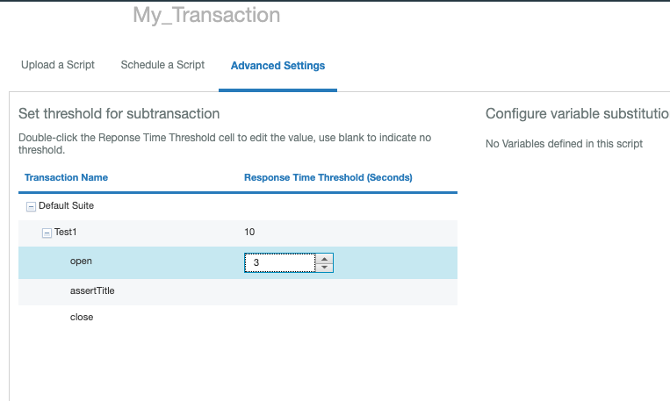

After you pressed ‘Save Transaction’ :
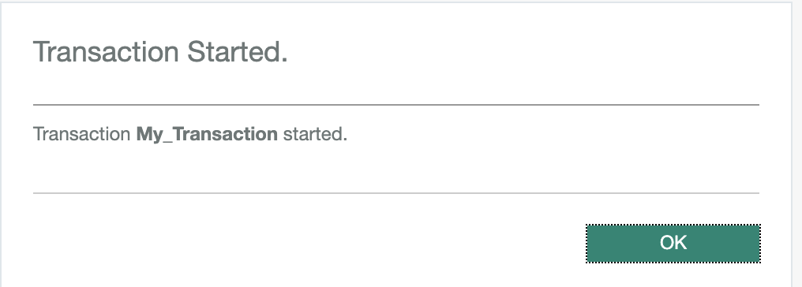

And your transaction should start and should appear in the list, under Synthetic Script Manager:
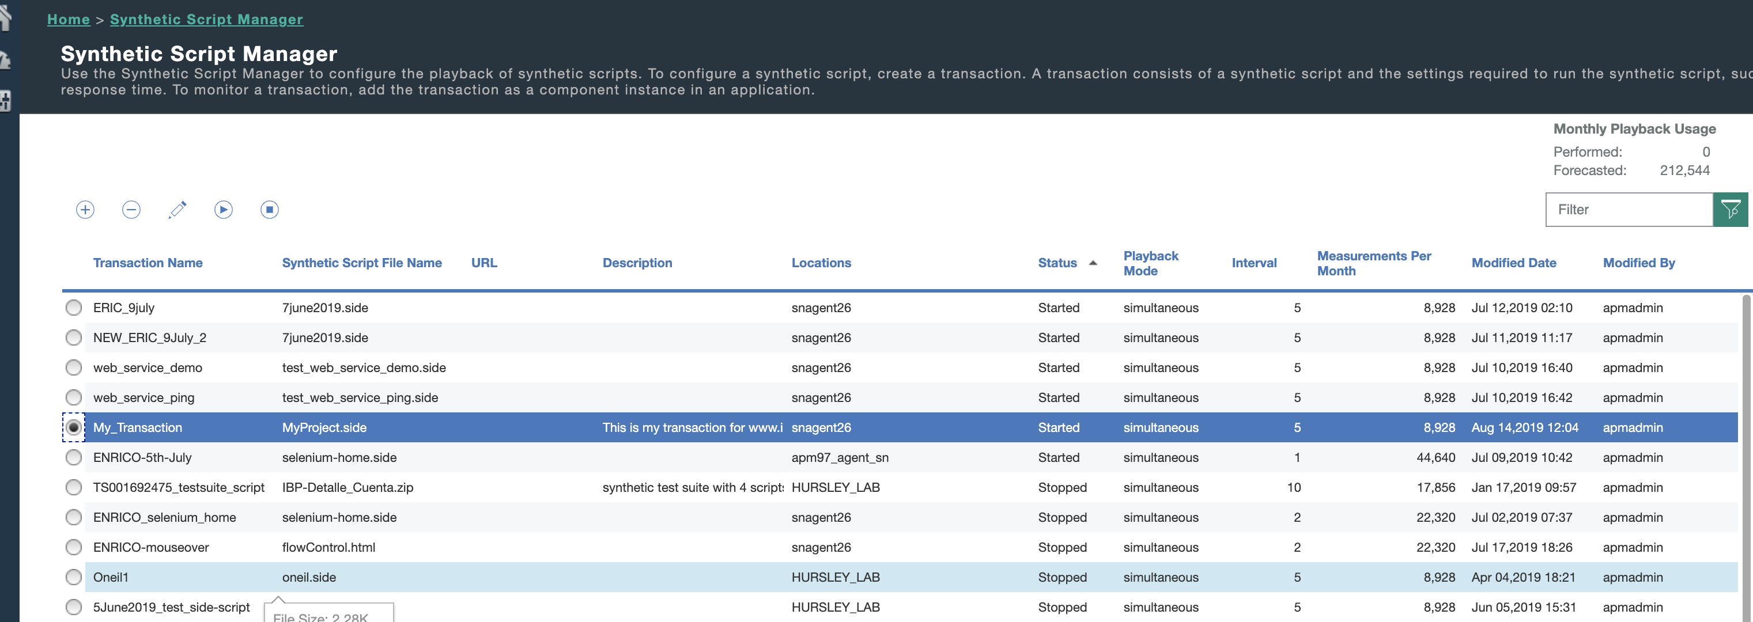

And monitoring results are available for your transaction in APM UI -> Application dashboard -> My Transactions -> Synthetic Transactions:
